**Note :-** We need to install and configure the application – Maven, Java, GIT ,terraform.

After Installation of each application need to configure each application.

Step are at bottom of Document. Step is same for all application.

We need to set the Path of application where you have installed the application.

Use Ctrl + Right click for config step **Step-To-Configure****:-**

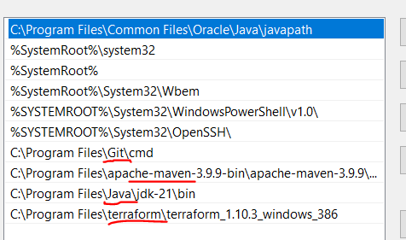

Prepare your Laptop for Devops

1. Create aws free tier account.
2. Create azure free tier account.
3. Download and install Git on windows

<https://git-scm.com/downloads/win>

#git --version

Download, install and configure java 17 on windows

1. Before downloading check, java is installed in your laptop or not. Uninstall java if the version is not 17

<https://www.oracle.com/in/java/technologies/downloads/#java21>

|  |  |  |
| --- | --- | --- |
| Windows x64 MSI Installer | 152.66 MB | [https://download.oracle.com/java/21/latest/jdk-21_windows-x64_bin.msi (sha256)](https://download.oracle.com/java/21/latest/jdk-21_windows-x64_bin.msi%20(sha256)) ([sha256](https://download.oracle.com/java/17/archive/jdk-17.0.11_windows-x64_bin.msi.sha256)) |

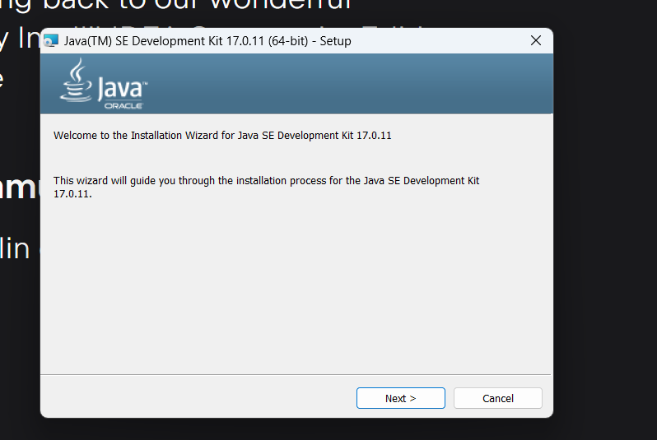

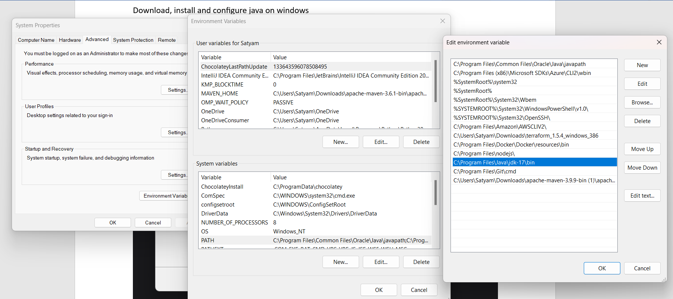

#java –version

#javac --version

Download and Configure maven on windows

<https://maven.apache.org/download.cgi>

Note : Maven is dependent on Java

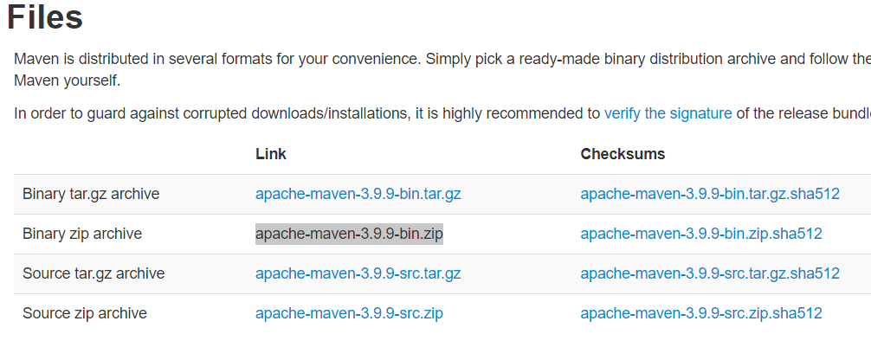

Download and Unzip the maven folder

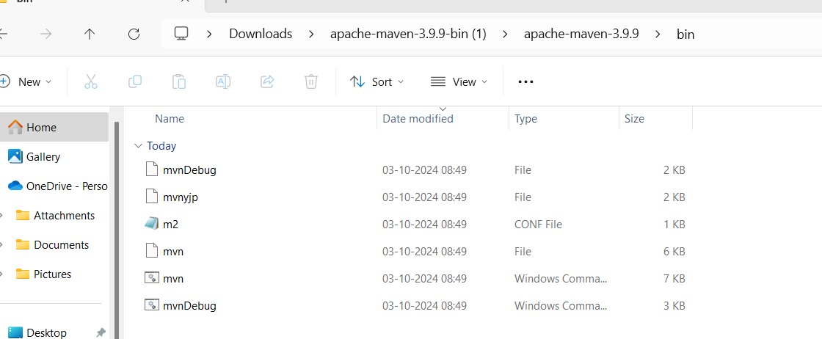

Set The System env variable for Maven

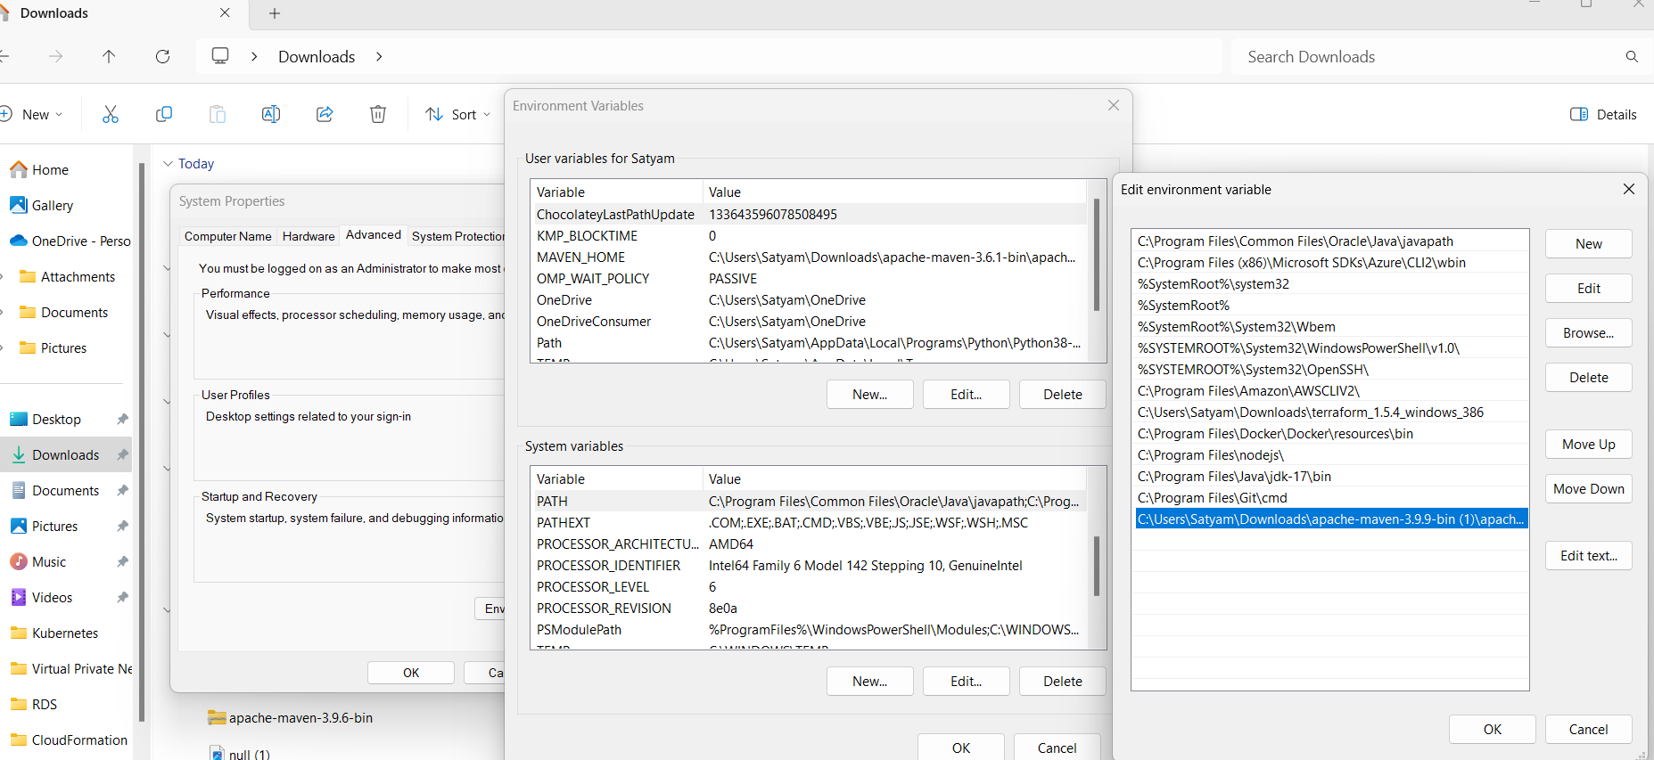

Open the command promot and run the command #mvn –version

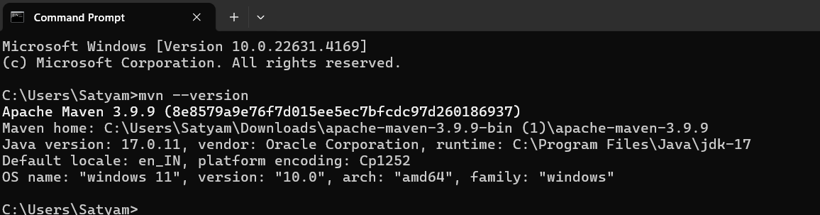

Download and install Intelli Idea Community edition

<https://www.jetbrains.com/idea/download/?section=windows>

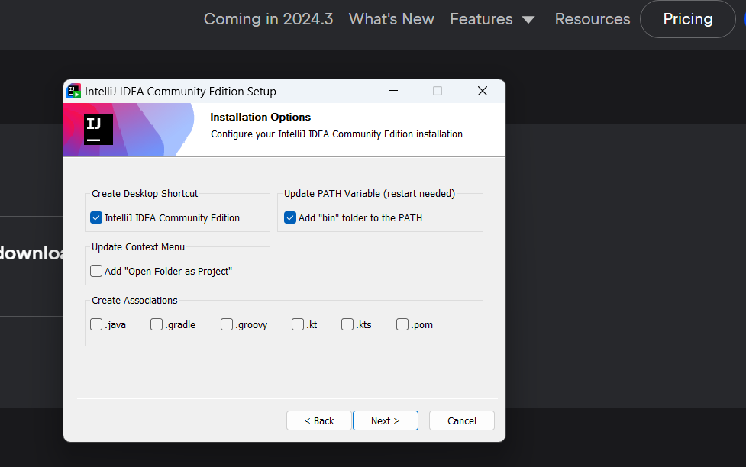

Create Github Account

Open <https://github.com>

Enter your email id

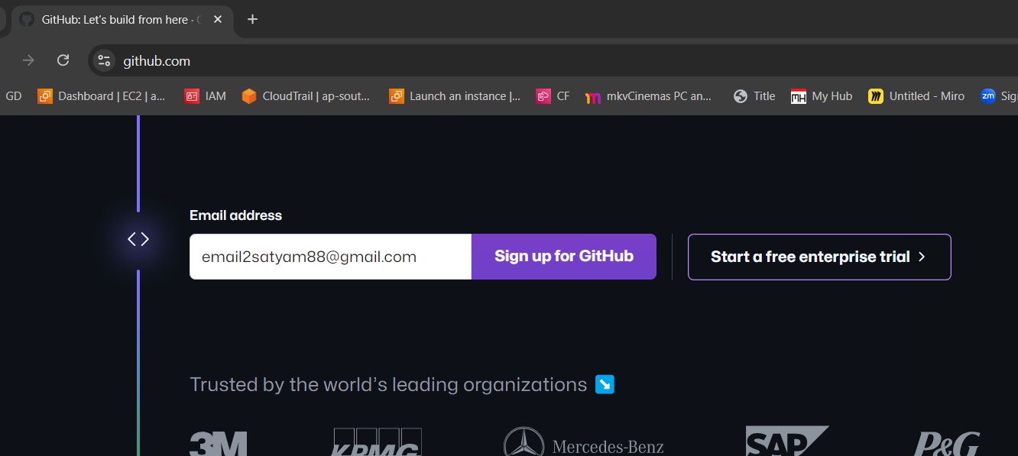

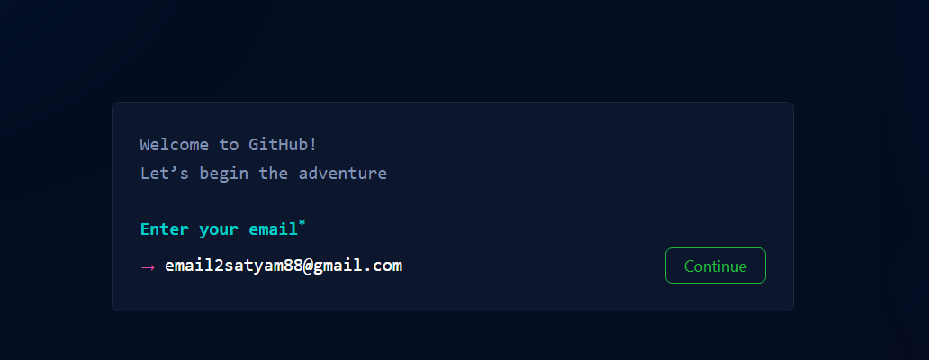

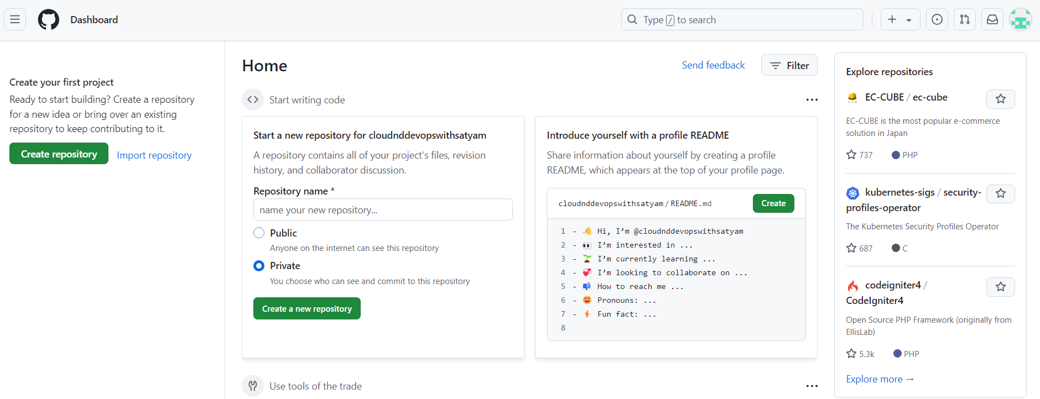

**Download Terraform**

<https://developer.hashicorp.com/terraform/install>

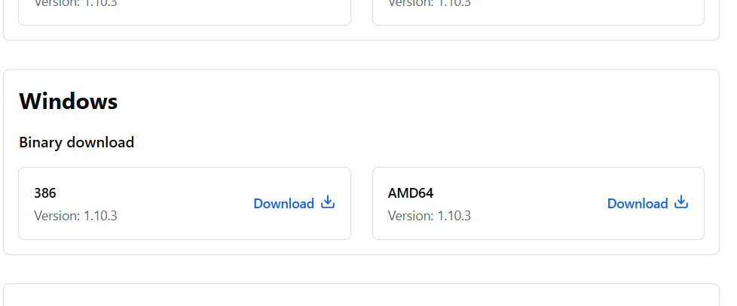

**Step-To-Configure:-**

1)step- Click on Environment Variables for you account

2)click on Environment Variable

3)click on path which is under

4 ) Add the path and click ok,ok,ok. Then close the CMD and open again. And check the result.

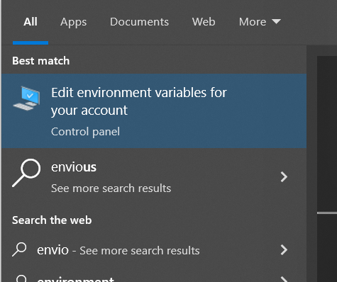 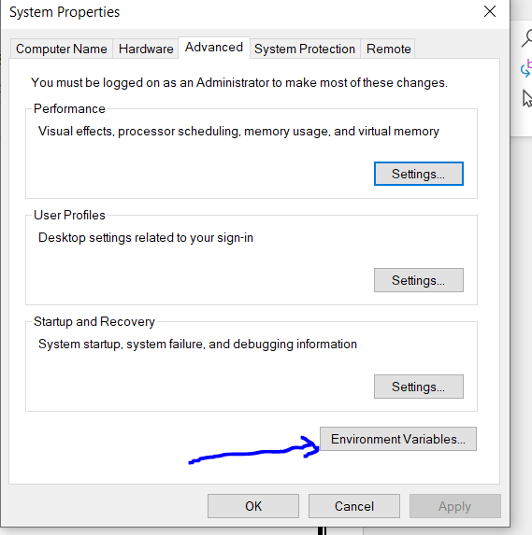

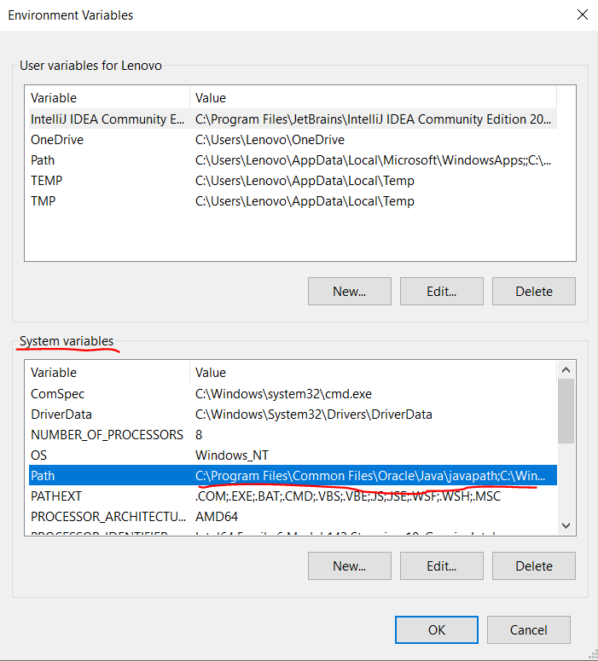 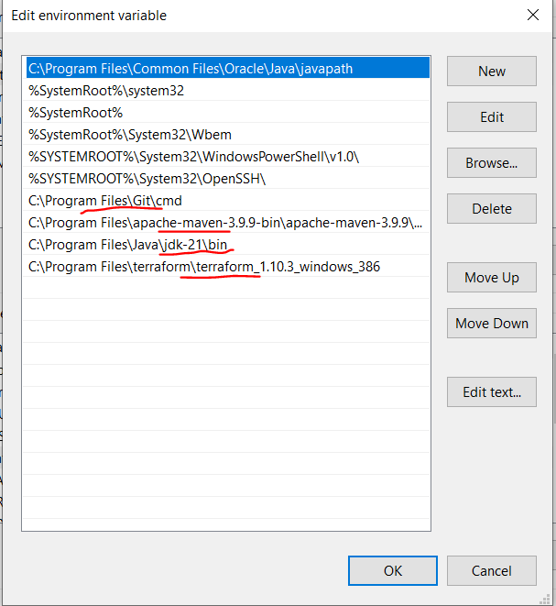

**Result –**

